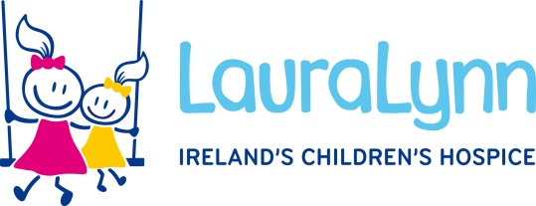

Title: Family Events Coordinator
Hours: 35 Hours
Contract Type: Permanent
Grade/Salary: Grade VI salary scale - €55,093 - €67,308
Job Closing Date: 12pm, 21st July 2024

Summary of the role:
LauraLynn is seeking to recruit a Family Events Co-ordinator who will be part of the Operations Team and report directly to the Head of Operations.

The ideal candidate will have a genuine interest in supporting families facing challenging circumstances and possess excellent organisational and interpersonal skills.

The Family Events Co-ordinator will be responsible for planning, coordinating and executing a variety of events and activities and managing associated administrative systems, geared towards supporting families, creating lasting memories and fostering a sense of community within LauraLynn Hospice Services nationally.

The role will work closely with other members of the Hospice Management Team, Family Support Team, Nursing Team, Operations Team and Marketing & Communications Team, in enhancing the family experience of LauraLynn events.

The duties of the position will vary and will require an ability to prioritise tasks, collaborate closely with colleagues and peers and to use own initiative in managing the workload. Some reasonable out of hours work and travel to LauraLynn regional sites and events will be required. Hybrid working is an option for this role with a minimum three days working onsite; flexibility will be required, relevant to demands of the role.

Benefits:

- Strong sense of purpose and meaning
- Flexible working options
- Learning & development opportunities
- Pension Scheme
- Comprehensive induction programme
- Extensive in-house person-centred training programme for nursing, clinical and care staff
- Generous annual leave
- Active wellbeing supports including an inhouse occupational health service and a free 24/7/365 employee assistance programme (EAP) for staff and their immediate family members
- Subsidised canteen
- Free car parking
- VHI group scheme
- Membership to HSSU Credit Union
- Bike to work scheme

Essential Criteria - ideally the successful candidate will possess the following:
- Minimum level 6 or equivalent qualification in one of the following: event management, project management or equivalent.
- A minimum 3 years continuous experience in a similar role with demonstrable experience in event management and/or project management.
- Experience in coordinating the delivery of a variety of events and activities concurrently.
- Experience of managing suppliers, budget management and working across departmental functions.
- Experience of person-centred event or service design and/or delivery.
- Experience of leading/working in cross functional teams.

Please note that whilst this position is not publicly funded the salary is linked to the national pay scales.

How to Apply:
For a full job description and person specification contact our HR Department, E: hr@lauralynn.ie
For informal enquiries please contact Bevan Ritchie on 01 2893151 or E: britchie@lauralynn.ie
Should you need assistance or have any special needs when attending for interview please contact any member of the HR team and reasonable accommodation will be arranged.

