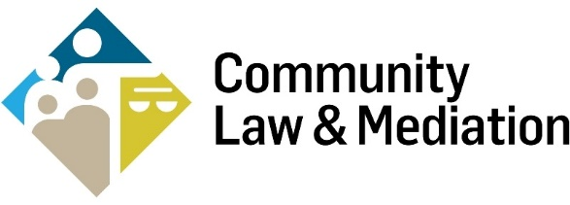

JOB DESCRIPTION FOR THE POSITION OF LEGAL OFFICER (FIXED TERM CONTRACT)

Job Title | Legal Officer
Employer | Community Law & Mediation (CLM)
Reports to | The direct line report is to the Housing and Social Welfare Solicitor. The successful candidate will also report to the legal team.
Salary | Details available on request
Hours | 26 hours/4 days per week (9.30am – 5pm)  CLM is open to flexibility on how these hours are worked.
Duration of Contract | Fixed term for 2 years, subject to successful completion of a six month probation period. It is hoped to secure sufficient funding to enable the role to be full time (5 days per week) and longer term.
Start Date | 2 September 2024 or as soon as possible thereafter
Location | CLM Offices, Northside Civic Centre, Bunratty Road, Coolock, Dublin 17. Some travel may be required. CLM’s current remote working policy provides that staff work 2 days per week in the office.
Application Deadline | 5pm, Monday 29 July 2024
Proposed Interview Date | Week commencing Monday, 5 August 2024

Background to CLM
Community Law & Mediation (CLM) is a community based, independent law centre providing services nationwide and operating in two locations: Dublin and Limerick. It was founded in 1975 and assists more than 6,000 people annually through its services, which include free legal advice and representation; information and education; and mediation and conflict coaching. CLM also campaigns for law reform, and for the safeguarding of rights already enshrined in law.

Our legal team has represented clients for nearly 50 years in some of the ground-breaking human rights cases in Ireland.
For further information, please visit our website.

The Role of Legal Officer
This is a unique and exciting opportunity for someone seeking experience in public interest and human rights law in one of the leading independent law centres in Ireland.
The successful candidate will play an important role in supporting the legal team to provide legal advice and representation to clients in the area of social housing, social welfare, employment and equality cases.

Key Responsibilities
- Support the progression of social housing, social welfare, employment and equality cases
- Legal research and contribution to the policy and law reform work of CLM, as required
- Attend client meetings and court with legal team
- Provide administrative support to the legal team including typing, preparing briefs and filing documents in court
- Maintain client files and records in line with file management procedures
- Design and deliver Know Your Rights talks to the community
- Such other tasks as may be necessary to assist with the work of the legal team

Person Specification
Essential
- Degree in law or other relevant third level qualification
- Strong research skills
- Proven organisational and administration skills with good attention to detail
- Excellent verbal and written communication and presentation skills
- Strong IT skills, proficiency in MS Office
- Ability to meet targets and work to deadlines
- Strong ability to work effectively as a member of a team
- Responsive and adaptive to a dynamic work environment
- Enthusiasm and commitment to social justice and equality

Desirable
- Experience working in a legal office
- Demonstrated interest in social justice and equality

Application
Please email completed application form and CV, as one document, to Mary Heavey at mary.heavey@communitylawandmeditation.ie.
The closing date for receipt of applications is Monday, 29 July 2024. Interviews will be held on the week commencing Monday, 5 August 2024.
To view CLM’s fair processing notice, please click here.
Community Law & Mediation is an equal opportunities employer.

