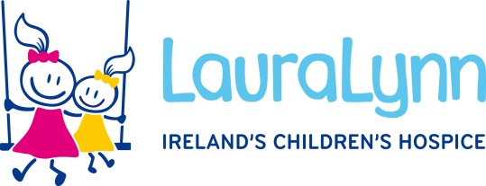

**Title:** Regional Fundraiser – Munster Region

**Hours:** 30 hours per week

**Contract Type:** Permanent

**Grade:** V

**Salary:** €49,702 - €59,457

**Job Closing Date:** 5pm, Friday 6th September

**Summary of the role:**

LauraLynn’s Fundraising strategy (2023-2027) aims to significantly grow fundraised income over the next few years. A key part of this growth will come from expanding our fundraising presence nationally, in line with our extended Care services. Corporate & Community income has always formed a central pillar in LauraLynn’s income generation, and we need to expand our presence nationally to help drive income growth in this area.

This is an exciting opportunity to join a dynamic Fundraising Team and develop our first ever regional fundraising presence in the Munster region, based in our office in Mallow. Reporting directly to the Head of Corporate & Community Fundraising, the successful candidate will primarily focus on generating local support for LauraLynn in the Munster region driving the growth of Corporate and Community income, through establishing local corporate partnerships and developing and maintaining new initiatives and campaigns in partnership with the current Corporate & Community Fundraising Executives. The new Regional Fundraiser will also work very closely with the Care team in Mallow cultivating strong, collaborative and positive relationships.

**Benefits:**

* Strong sense of purpose and meaning
* Flexible working options
* Learning & development opportunities
* Pension Scheme
* Comprehensive induction programme
* Extensive in-house person-centred training programme for nursing, clinical and care staff
* Generous annual leave
* Active wellbeing supports including an inhouse occupational health service and a free 24/7/365 employee assistance programme (EAP) for staff and their immediate family members
* Subsidised canteen
* Free car parking
* VHI group scheme
* Membership to HSSU Credit Union
* Bike to work scheme

**Essential Criteria - ideally the successful candidate will possess the following:**

* Educated to third level preferably in Business, Marketing, PR or Events
* A minimum of 3 years experience in a fundraising role within a charity or related environment
* Experience of leading and organising successful fundraising, sales, campaign events
* Experience building relationships and high value partnerships with individuals, companies or groups
* Experience of CRM databases

Please note that whilst this position is not publicly funded the salary is linked to the national pay scales.

**How to Apply:**

For a full job description and person specification contact our HR Department, E: [**hr@lauralynn.ie**](mailto:hr@lauralynn.ie)

For informal enquiries please contact Gillian Neary**,** on 01 2893151 or E: [gneary@lauralynn.ie](mailto:gneary@lauralynn.ie)

**Should you need assistance or have any special needs when attending for interview please contact any member of the HR team and reasonable accommodation will be arranged.**