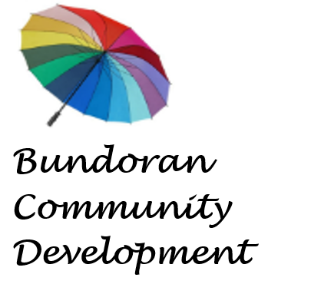

Job Advertisement

‘The W-A-Y’ Project
Youth Development Project Co-ordinator

Bundoran Community Centre, Co. Donegal
Bundoran Community Development CLG trading as ‘Bundoran Community Centre’ is a multi-purpose community centre located on the Main Street in Bundoran and also at the former Council Offices at Station Road in the town. We are a voluntarily governed community organisation and a registered charity which is at the heart of all aspects of the social, cultural and community life of the area. We are currently recruiting for a skilled Youth Development Project Coordinator to join our team. The coordinator will lead the implementation of the Wild Atlantic Way (The W-A-Y) youth development project that supports the development of young people aged 16-25 years living in the South Donegal area.

Role | Youth Development Project Co-ordinator
Salary | Salary €35,000 - €37,500 (under review)
Employer | Bundoran Community Development Company Limited by Guarantee
To apply: | To apply submit a CV and Cover Letter to bccjob24@gmail.com outlining relevant experience
Closing Date: | Immediate Vacancy - apply by 6th December 2024.


Funded by the International Fund for Ireland (IFI)
under the Personal Youth Development Programme (PYDP)

