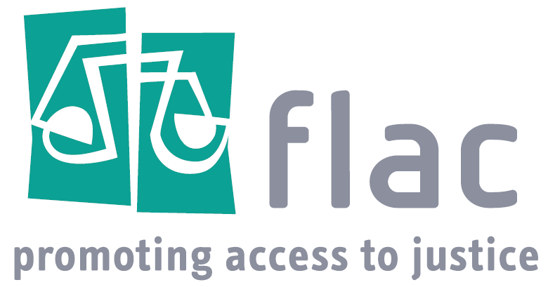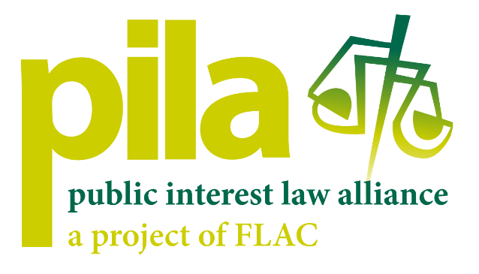

Invitation to Tender
Evaluation of FLAC’s project, the Public Interest Law Alliance (PILA)

Background
FLAC as one of Ireland’s oldest civil society organisations has been advocating for access to justice for over 50 years. It operates in a number of ways:
- Operates a telephone information and referral line where individual callers are provided with basic legal information.
- Runs phone legal advice clinics where volunteer lawyers provide basic legal advice.
- As an Independent Law Centre, it takes cases in the public interest
- FLAC’s Independent Law Centre also runs three targeted legal services, the Traveller Legal Service, the Roma Legal Clinic and LGBTQI+ Legal Clinic.
- Campaigns for policy and law reform in areas of law that most affect disadvantaged and marginalised people and communities through research and advocacy.

PILA
In addition, FLAC operates the Public Interest Law Alliance – PILA.
PILA is a project of FLAC that engages the legal community and civil society in using the law to advance positive social change. It was stablished in 2009 following a three-year grant from Atlantic Philanthropies to “support the advancement and protection of human rights through the use and promotion of public interest law and strategic litigation in Ireland”.

Four key pillars guided the activities of PILA: law reform, legal education, community legal education and strategic public interest litigation. In line with these, PILA carries out the following activities:

- Champions pro bono work in Ireland. PILA developed a pro bono referral scheme to connect with NGO’s with a legal need. Acting as a clearing house, PILA assists social justice NGOS to access varying types of legal assistance (e.g. training, legal advice, litigation, law reform.) PILA hosts the Pro Bono Portal in Ireland, an online platform used to manage pro bono referrals by clearing houses worldwide.
- Promotes public interest litigation by undertaking legal research, supporting ongoing casework, linking cases with wider campaigns and seeking representation for marginalised and disadvantaged groups. We also publish the PILA Bulletin which shares information regarding initiatives, cases and events in the area of public interest litigation.
- Creates signature ‘Impact Projects’ between civil society organisations with a long-term legal need and volunteer lawyers or law firms. PILA also organises relevant or specialised training sessions if needed. An example of an Impact Project can be seen here.
- Organises legal education sessions for NGO staff on common legal issues facing their organisations. The most recent education sessions were delivered on immigration law, defamation and governance. PILA also organised a legal information clinic specifically for Ukrainian nationals living in Ireland.
- Since 2020, PILA facilitates the operation of the Pro Bono Pledge Ireland. The Pledge provides a common definition of pro bono, a commitment to a minimum aspirational target of 20 pro bono hours per lawyer per year, and a mechanism to benchmark progress through annual reporting of anonymous pro bono data to PILA. It was developed by an independent grouping of law firms, barristers, and in-house legal teams. PILA maintains the signatories register and the Pro Bono Pledge Website. It also organises NGO Pitch events for civil society organisations to pitch their legal needs to a panel of Pro Bono Pledge Signatories, with a view to forming long-term partnerships or bespoke projects with signatories.
- PILA also provides support to Pro Bono Week Ireland which takes place at the same time as European Pro Bono Week each year. Pro Bono Week is a significant week-long event to celebrate and highlight the role played by lawyers in supporting civil society and human rights organizations, and in turn promoting access to justice for those in need.
- For many years, PILA supported clinical legal education by working with law schools to develop new initiatives during 2009 - 2015.

Central to the successful operation of PILA over the past 15 years has been its structure combining core staff, an alliance of social justice NGOS and lawyers in private practice, and in more recent years PILA has been supported by sustaining and supporting partners.

The PILA Alliance
The PILA alliance is made up of lawyers challenging injustice, law schools and their students channelling future change, non-governmental organisations (NGOs) fighting for those on the margins, and Independent Law Centres at the frontline of public interest law practice in Ireland.
We currently work with 45 law firms with over 2000 solicitors, 8 in-house legal teams, more than 350 barristers, 12 law schools, and 170 NGOs and Independent Law Centres.

Context for review
After 15 years of operation PILA is now operating in a very different legal landscape. Over that time pro bono culture in Ireland has developed. There are now dedicated pro bono associates and pro bono partners working full-time or part-time in the area of pro bono who can and have built up relationships with the NGO sector.
PILA is increasingly receiving requests for assistance from organisations that do not come within the original remit of social justice NGOs seeking to advocate for change in law or policy. FLAC’s telephone information and referral line witnesses huge unmet legal need from individuals who do not belong to NGOs. There is also an increased number of queries relating to charities’ boards of trustees and the Charity Regulatory Authority.
A commitment in FLAC’s last strategic plan is to review all of its information and advice services. The operation of PILA, as a project within the wider context of FLAC, also requires review given the challenges faced in terms of funding, resource allocation, staffing and feedback regarding its identity and relationship with FLAC.
FLAC is therefore seeking an evaluation of the operation of PILA, both in terms of its internal operation within FLAC and externally regarding its ability to achieve the originally established objectives.

Evaluation questions:
The evaluation will assess the relevance, effectiveness and impact of the PILA project. Specifically, the evaluation will consider the following questions:
- To what extent has PILA fulfilled its original objectives? Do these remain relevant and appropriate in the present context and the developments that have occurred?
- To what extent has PILA facilitated social justice NGOS (members of the PILA Alliance) to obtain legal assistance? What type of NGOs have received such assistance and over what timeframe? What is the nature of the assistance that has been received? And by whom?
- Should the Pro Bono Referral Scheme broaden its referral range beyond social justice NGOS who are advocating for change? Should the work of PILA be extended to include a wider range of NGOs, charities, or other bodies who are not advocating for changes to the law?
- How should PILA’s criteria change to adapt to the new pro bono environment and to the unmet legal needs of the community?
- What are the core needs of social justice organisations in terms of legal assistance? Are there any particular areas of law or types of assistance, where there is a dearth of assistance available?
- What is the need for PILA in the changed environment? Can it be made more effective and sustainable given funding, resources and broader issues within the legal landscape?
- On an organisational basis, what are the advantages and disadvantages of PILA and its activities remaining as a separate project within FLAC with it is own branding and staff?

Timeframe
It is proposed that the evaluation be completed within two months. The schedule will be agreed by the project team and evaluator. The evaluator will produce a report.

Methodology.
In terms of the methodology, FLAC is open to exploring the overall approach to the evaluation. However, we expect the methodology to include a combination of;
- Desk research which would include a data review of internal documentation generated by the PILA’s staff in the course of the Pro Bono referral scheme.
- Interviews with key internal and external stakeholders and informants including:
  - Staff and FLAC council consultation: engagement with key staff and board members on a collective or individual basis.
  - Key informant interviews: Interviews with external stakeholders to PILA who have an informed view about the PILA’s performance – this may include a selection of NGOS who have used PILA’s service, NGOs who have not engaged with PILA, lawyers of the alliance, sustaining partners, the Voluntary Assistance Scheme of The Bar of Ireland, relevant representatives from the legal profession, Government Departments, funders, and international experts on pro bono.
- A questionnaire will be agreed.

Ethics and values
We expect the successful evaluator/team of evaluators to adhere to FLAC’s policies and values. The successful evaluator/team of evaluators should also adhere to ethical and professional standards set out by professional evaluation associations.

Accountability
The evaluation is accountable to the PILA review team, which includes the FLAC CE.
Communications with the team will be conducted via the Project Coordinator, and the FLAC CE. The successful evaluator(s) will be expected to:
- Maintain regular contact with the Chief Executive.
- Attend regular meetings with the Chief Executive and the PILA review team, as appropriate.
- Be flexible and responsive to the needs of the organisation as they arise.
The PILA review team will approve the evaluation report.

Competency and expertise requirements
The successful evaluator(s) will:
- Have a proven track record in evaluation, including for rights-based and advocacy organisations.
- Demonstrate an understanding of and have experience of organisations working in the community and voluntary sector.
- Provide details of relevant experience and qualifications in delivering on all aspects of the tender and provide two referees.
- An understanding of or familiarity with the legal system would be a distinct advantage

SUBMISSION OF APPLICATIONS
Interested candidate(s) should submit:
- A CV or resume for the individual or members of proposed team.
- A technical proposal explaining their comprehension of the terms of reference and how they would approach this assignment within the given time (3-page maximum),
- Two samples of similar previous assignments,
- A financial proposal outlining their expected fees and other expenses.

Award Criteria
- Methodology 35%
- Schedule 15%
- Experience/skills of evaluator/evaluation team 35%
- Cost 20%

The closing date for receipt of tenders;
All documents need to be submitted by email to pila@flac.ie by 5pm Monday 23 December 2024.

Tenders will be accepted by email only. The onus is on the applicant to ensure their tenders have been received on or before this deadline. Requests for further information and completed proposals should be marked for the attention of: Demetra Herdes.

