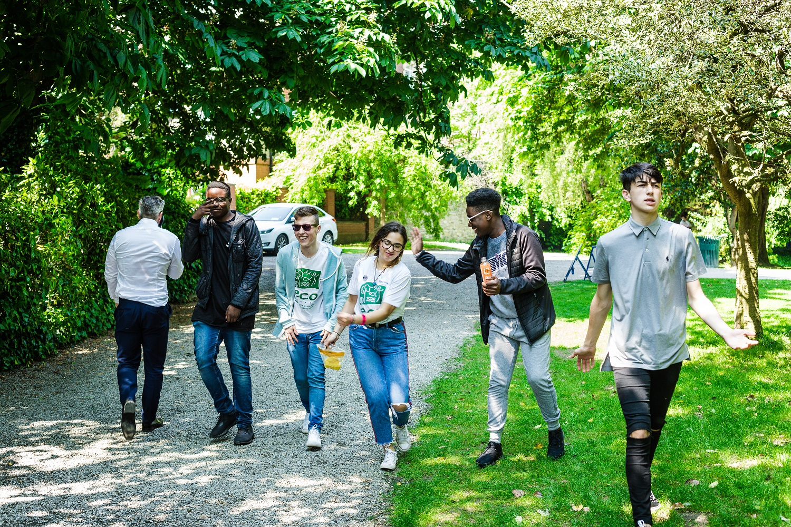

Candidate Information Pack
Programme Officer– ECO-UNESCO Clubs &
Champions
ECO-UNESCO
2025

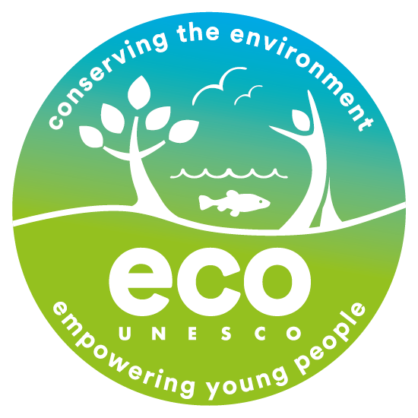

About ECO UNESCO
We are Ireland’s leading environmental education, training and youth organisation and a Quality and Qualifications Ireland training Centre (QQI), working with over 10,000 young people annually. We seek to raise awareness of environmental issues by channelling the passion, creativity and energy of young people into positive environmental action. ECO-UNESCO delivers a wide range of youth, education, and training programmes across Ireland to promote the personal development of young people through practical environmental projects. Through our range of programmes and services we inspire, educate, empower, and support young people to act.

We work
“Our vision is a sustainable world where young people are actively engaged in protecting the environment.”

- across the island of Ireland
- to conserve the environment and empower young people.
- with young people in formal and nonformal settings, in secondary schools, youth services and communities across Ireland through our Young Environmentalist Awards, workshops, trainings or one of our affiliated ECO-UNESCO Clubs.
- and with partners in Europe and internationally.

Our Mission
Our mission is to protect the natural environment and empower young people by developing their knowledge, skills and confidence that channels their passion into positive and creative actions that helps create a sustainable planet. We do this by:
- Raising awareness, understanding and knowledge of the natural environment among young people.
- Engaging, inspiring and empowering young people by facilitating their personal development and well-being through practical environmental projects, activities and skills development.
- Promoting the protection and conservation of the environment by empowering young people to lead in action oriented environmental projects and activities and by promoting positive and environmental behaviour.
- Advocating for environmental education, education for sustainable development, the natural environment and youth development.
- Promoting the ideals of UNESCO and working with likeminded organisations in Europe and globally.

Our Values
We have respect for young people, our participants, volunteers, employees, and our stakeholders. In our work we have a passion for the environment and for our young people, and an acknowledgement that the natural environment plays an important role in all our lives and in the development and education of our young people. We value youth-led approaches, creativity and innovation, action based learning, and fun as we work together to protect the environment and impact the lives of young people.
What we do
ECO-UNESCO’s programmes empower and support young people to take action to protect and conserve the natural environment.
- We take a youth centred approach and promote learning for, about and in the environment
- We develop leadership skills, confidence, self-belief, and self-esteem
- We provide an opportunity for young people to feel socially engaged and make new friends
- We include young people’s views – they decide, they plan, they act, and they engage their peers.
How we do it
Our work can be broken down into the following categories;

Environmental Youth Work
- Youth for Sustainable Development and Peer Education Programme
- Environmental youth events, activities, and workshops
- Clubs Programme
- ECO-Youth Choices Health & Wellbeing
- International Youth Summit - #NoTimeToWaste
- Youth Climate Justice
Capacity Building and Training
- Green Youth Employment programmes
- Information and support provided to educators, youth leaders and young people
- Training including QQI accredited courses delivered to a wide audience
- Key Partner of the UNESCO Global Action Programme in Education for Sustainable Development
Awards
- Our Annual Young Environmentalist Awards
Other Activities
- Development of environmental education resources
- ECO-Sustainability Award for organisations
- Representation and advocacy for environmental education and education for sustainable development (ESD)
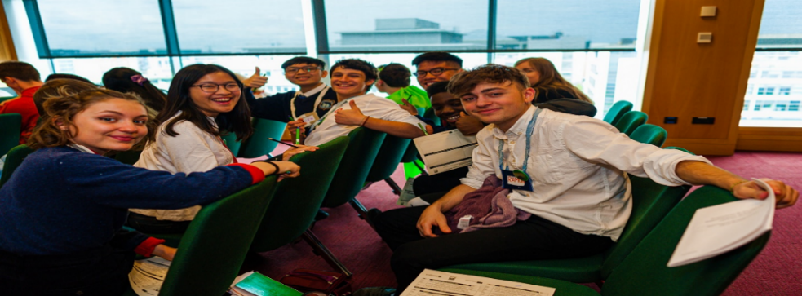

ECO-UNESCO Clubs & Volunteer Programme Officer
This is a great opportunity to join an organisation that is protecting the natural environment and making a real difference to the lives of young people. If you have a passion for our natural environment, for youth development and are enthusiastic and motivated with a background in sustainability, then we would love to hear from you.

Contract: Fixed Term – 10 months*
Probationary period: 6 months

Reporting to: | YSGC Programme Coordinator
Location: | ECO-UNESCO’S Headquarters at 9 Burgh Quay, Dublin 2 with nationwide travel required.
Time commitment: | Full time (28 hours)  Flexibility is required as the role includes evening and weekend work.  Fixed Term Contract (*this contract is linked to specific project funding from DCEDIY)
Start Date: | Immediate
Salary: | Starting Salary scale €26,000 – €27,000. Starting salary dependent on experience

Benefits
- 21 days annual leave per year which increases annually to a maximum of 25 days per year.
- An employer matched pension scheme is available after a qualifying period.
- An Employee Assistance Programme is available to all staff.
- Use of a Mobile Phone & Laptop
- Access to company car (when needed for work travel purposes)
- Bike to work scheme & TaxSaver travel scheme
- Exam and study leave

About The Role
ECO- UNESCO seeks to employ a Programme Officer for our ECO-UNESCO Clubs & Volunteer programme. This is a position of responsibility within ECO-UNESCO, with line management responsibility. You will coordinate the delivery of our ECO-UNESCO Clubs & Volunteer programme across Ireland. This includes supporting existing clubs and setting up new clubs in locations around Ireland. This will include recruiting and training of Volunteers to support the Clubs, recruitment of participants, with Volunteers and young people develop Clubs programmes and content; support in delivery of workshops, organising Clubs and Volunteer meetings and events. The ECO-UNESCO Clubs and Volunteer programme is a comprehensive programme funded by the DCEDIY through Volunteer Activation Fund
Key Responsibilities
Development and Implementation
- Assisting the ECO-UNESCO Clubs and Volunteer programme & initiatives as outlined in the YSGS Volunteer Activation Fund application
- Support existing ECO-UNESCO Clubs and establish new Volunteer-Led ECO-UNESCO Clubs in regional locations.
- Coordinate the recruitment, retention and training of local Volunteers to support Clubs
- Roll out a series of Volunteer support sessions, trainings and networking events
- Assist in implementing training programmes including adult and youth trainings.
- Assist with organisational events, including youth summits and the Young Environmentalist Awards.
- Research and write materials as needed.
- Develop and deliver identified outreach workshops.
- Coordinate international training programmes.

Promotion:
- Promote ECO-UNESCO’s clubs, volunteer programme through talks and presentations.
Fundraising & Grant Writing
- Complete funding applications and reports.
- Identify additional funding opportunities for ECO-UNESCO’s Clubs & Volunteers and development education programme and assist in ECO-UNESCO’s response to these.
Other
- Maintain all relevant files and records, including Salesforce.
- Write/complete reports on a regular basis.
- Undertake any other such relevant duties as directed.
- Assist in delivery of ECO-UNESCO’s other programmes as needed. Periodic assistance is required from all staff for our annual Young Environmentalist Awards, Youth Summits, and other large events.
This role description is not to be regarded as exclusive or exhaustive. It is intended as an outline indication of the areas of activity and can be amended. ECO-UNESCO reserves the right to reassign staff as appropriate and necessary.

Person Specification

Qualifications
- 3rd Level Qualification in a related field – in sustainable development/environmental studies or science / ecology/biology/ geography/ education (Essential)
- An education or youth work qualification (Desirable)
Experience
- At least 2 years' work experience in direct work with young people (10-18); youth work, education, and/or environmental education/sustainable development and /or in a similar youth scheme/programme (Essential)
- Experience working with volunteers and in delivering youth programmes (Essential)
- Demonstrable organisation skills, having managed multiple priorities and adherence to deadlines (Essential)
- A strong interest in environmental education and working with young people (Essential)
- Budgetary management experience from initial planning through to end of project reporting (Desirable)
- A full, clean driving license (Essential)
Knowledge and Skills
- Knowledge of the youth work sector and education system in Ireland (Essential)
- Knowledge of education for sustainable development/development education in Ireland (Essential)
- Excellent organisational skills (Essential)
- Excellent communications and interpersonal skills (Essential)
- Excellent report writing, analytical and computer skills (Essential)
- Ability to work to tight deadlines and under pressure (Essential)
- Ability to manage a complex workload (Essential)
- Working knowledge of IT systems (Essential)
- Ability to critically analyse data and make appropriate decisions (Desirable)
Disposition
- Be a self-starter with a positive, can-do attitude (Essential)
- Be a problem solver and creative (Essential)
- Be dependable and flexible (Essential)
- Be able to take direction (Essential)
- Be committed to working as part of a team (Essential)
- Be committed to the values and principles of ECO-UNESCO (Essential)

ECO-UNESCO is an equal opportunities employer, and all employees are expected to develop an understanding of and commitment to equal opportunities.

How to apply

Please send a copy of a completed Application Form with a Cover Letter to: recruitment@ecounesco.ie
Please mark in subject line Employment Opportunities – ECO-UNESCO Clubs & Volunteer Programme Officer (Private and Confidential)

Closing Date for Applications – Friday 4th April 2025
Interview Date – provisionally scheduled for week commencing 07th April 2025
Successful applicants may be requested to prepare a short presentation during the selection process.

Applicants may be placed on a panel for positions that may arise in the future.

By completing and submitting this form you consent to ECO-UNESCO processing the personal data provided to assess this application for employment. No further processing of your data will occur beyond this purpose. ECO-UNESCO will retain this application for up to 12 months, after which it will be deleted.

Due to the nature of this role, candidates will be subject to Garda Vetting.

ECO-UNESCO

APPLICATION FOR EMPLOYMENT

Please complete all sections of the form. CVs are not accepted, and no application will be processed if the form is incomplete.

Position applied for: | ECO-UNESCO Clubs and Volunteer Programme Officer
Where did you see the post advertised?

Personal Details
Title
Forename
Surname
Address
Please note, any successful candidate will have to be resident in Ireland upon taking up the position.
Phone
E-mail

Current or Last Employment
Position
Employer
Date from/to
Summary of achievements

Previous Employment (please add more rows if required)
Employer: | From: | To: | Position:
Summary of achievements:

Employer: | From: | To: | Position:
Summary of achievements:

Employer: | From: | To: | Position:
Summary of achievements:

Employer: | From: | To: | Position:
Summary of achievements:
Employer: | From: | To: | Position:
Summary of achievements:

Education and Qualifications
School / college / university… | From | To | Qualifications

Language Skills
 |  | Fluent | Moderate | Learning | None
ENGLISH (fluency essential) | Speaking
 | Writing
IRISH | Speaking
 | Writing
Add additional languages (with levels), or comments:

Experience & Skills
Please detail how your skills and experience meet the requirements set out in the job description. Before completing this section, please read the job description for this post carefully. For each item in the person specification (except formal qualifications already listed), you should give examples from your past employment, interests, voluntary work or life experiences to demonstrate how you meet the requirements of the post.

Statement in support of your application
Please outline your motivations for applying to this post.

Additional Questions
If successful, what is the earliest date that you could start the job?
Do you hold a current, full, and clean Driving License valid in the Republic of Ireland? |  |  | Yes / No  (Essential for this role)
Is there anything else you feel we need to know to support you in your application?
References
Please provide details of two referees, including your present or most recent employer. We will not contact your referees until we have contacted you and received your consent. Please ensure you have your referee’s permission to share their contact information.
1 | Name
 | Position
 | Address
 | Tel. No.
 | E-mail

2 | Name
 | Position
 | Address
 | Tel. No.
 | E-mail

Declaration
I declare that the statements made by me in this application are true and that the accuracy thereof shall be a condition of any contract of employment offered to me by ECO-UNESCO:

Signature of Applicant
Date

Please e-mail your completed form to recruitment@ecounesco.ie with Employment Opportunities – ECO-UNESCO Clubs & Volunteer Programme Officer (Private and Confidential) in the subject line.

Closing Date for Applications – Friday 4th April 2025
Interview Date – provisionally scheduled for week commencing 07th April 2025

